Guidelines for DBMS Mini-Project Report Preparation

Each student is required to write a comprehensive report about the project.

Number of hard copy reports for project should be

o Two copies if you are doing individually.

Your report should be organized as below,

- Cover sheet (With Page Border)

- Certificate (With Page Border)

- Abstract (NO border or header or footer, page number in roman)

- Acknowledgement (NO border or header or footer, page number in roman)

- Table of Content (NO border or header or footer, page number in roman)

- List of figures and tables (NO border or header or footer, page number in roman)

- Introduction (with header and footer, page number starts from 1)

- System Requirement

- Problem Description
- System Design (Design should include ER Diagram and Schema Diagram of your Database)

- Implementation (need not to have complete code, should contain important modules of your code)

- Screenshots

- Conclusion & Future scope

- Bibliography

Before taking final print out, the approval of the concerned guide(s) is mandatory and suggested corrections if any, must be incorporated.

- The margins should be left 1.25”, Right – 1”, Top and Bottom-0.75”.

- Cover sheet and Certificate should be in the specified format.

- Your report must have an abstract, not exceeding 100 words, summarizing the

aims, conclusions and implications of your project.

- Report should be spiral binded with CREAM color cover (cream is VTU color code

for CSE and you must follow it).

- Front sheet, Certificate and screenshots should be color prints. o Your report content should have following formatting,

  - The text should be in "TIMES NEW ROMAN ".

  - Body of the report should be divided into chapters, Sections and subsections.
- For each chapter the heading „CHAP TER number‟ must be left or right justified (Font size 16, Bold ) followed by the „TITLE OF THE CHAP TER‟ centered (font size 18, Bold).


- Section numbers along with their headings must be left aligned with section numbers and its heading in font size 16.

- Subsection and its heading in font size 14 - must be left aligned.

- The chapters, sections, subsections should be numbered in the decimal form. For e.g. chapter 2, sections as 2.1, 2.2 etc., and sub sections as 2.1.1, 2.2.2, 2.2.3 etc

- The body or the text of the report should have font size 12 and must be “Justify”aligned.
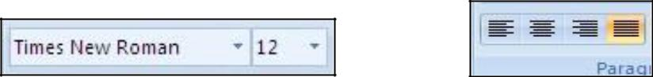

- Header should have "Title of your Project" in the left and "academic year" in the right.
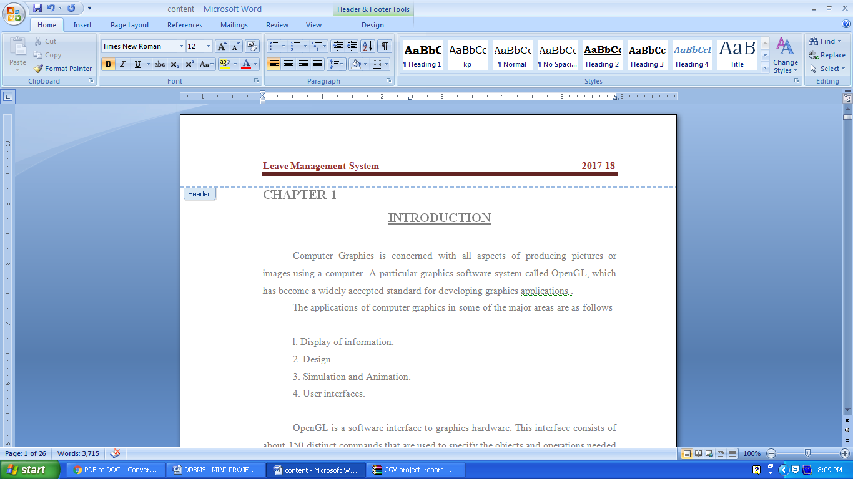

- Footer should have "V SEM,Dept of CSE” in the left, "page no" in the center and “MVJCE” in the right side.
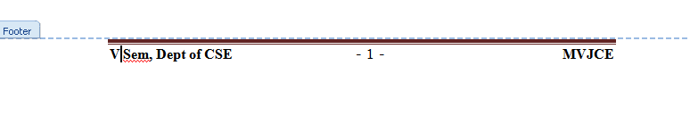

- Line spacing of the content should be 1.5.

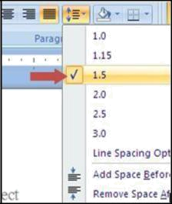

- All diagrams and screenshots should be numbered with respect to the chapter number. [E.g. Diagrams in chapter 5 should be numbered 5.1, 5.2, 5.3 etc... in the order].
- Abstract, Acknowledgement, Table of contents, List of figures and tables should have roman page numbers written at bottom (center) page. These sections should not have any headers or footers. The Roman numbering ends at List of figures and tables page, the subsequent chapter „Introduction‟ starts with page number 1.

- The last chapter should contain the summary of the work carried, contributions if any, their utility along with the scope of the further work.

✓ Reference or bibliography

is

not a chapter,

so

it should

not

have

any sort

of „CHAP TER number‟.

The references should be serially numbered

in the

order of their occurrence in text and their numbers should be indicated in [ ] brackets.
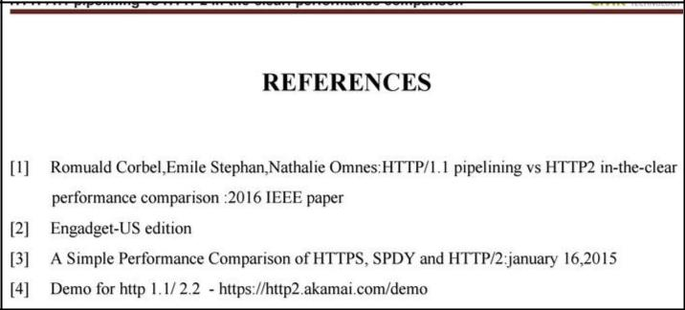

Proper attention is to be paid not only to the technical contents but also to the organization of the report and the clarity of the expression. Due care should be taken to avoid spelling and typing errors.

Mini Project Demo:

- You are allowed to show the working project in your laptop for the final review in the external lab exam.
- It is compulsory to keep a backup of the working code in a pen drive.

- You should compulsorily submit a CD to the department after the external lab exam. (Contents: softcopy of the Report, Working code). Write your Project name, name & USN on the CD.

